VDOT representatives will review and evaluate any information received as a result of the hearing.

Public hearing information, including the hearing summary, will be available for review at VDOT’s Lynchburg District Office located at 4219 Campbell Avenue, Lynchburg, VA 24501-4801.

After all comments have been addressed, the information received as a result of this hearing will be presented to VDOT’s Chief Engineer or designee for consideration.

If approval of the major design features is received for this project, it will move forward to the final design phase.

Ten days after this public hearing, the public comment period will close on April 30, 2023.
(May 7 if inclement weather date is used)

A comment sheet is enclosed and can be submitted at tonight’s hearing or by mail to Raina Rosado, P.E., Project Manager, Virginia Department of Transportation, 4219 Campbell Avenue, Lynchburg, VA 24501-4801. You may also email your comments to Raina.Rosado@VDOT.Virginia.gov. Please reference “Wards Ferry Rd. and CVCC Campus Dr.” in the subject line.

Information must be postmarked, e-mailed or delivered to VDOT within 10 calendar days of tonight’s hearing in order to be included in the hearing record.

© 2023 Commonwealth of Virginia

Welcome to the Virginia Department of Transportation’s (VDOT) design public hearing on a project to improve safety at the intersection of Wards Ferry Road and CVCC Campus Drive through the construction of a single lane roundabout.

This design public hearing is being held to provide an opportunity for citizens or organizations to give VDOT comments and/or suggestions on the proposed project. VDOT strives to ensure that all members of the community have the opportunity to participate in public decisions on transportation projects and programs affecting them.
VDOT representatives are present to discuss the project and answer your questions.

A comment sheet is included in the handouts for this meeting and your input is encouraged. All oral and written comments received on this project will be reviewed by VDOT personnel and will be available for review by citizens and other interested parties.

www.VirginiaDOT.org
Design Public Hearing
Wards Ferry Rd & CVCC Campus Dr
Intersection Improvement Project Lynchburg

Thursday, April 20, 2023, 4 – 6 p.m.
CVCC Merritt Hall
3506 Wards Road, Lynchburg VA 24502

https://www.virginiadot.org/projects/lynchburg/wards_ferry_road.asp
(Inclement weather date - April 27, same time.)

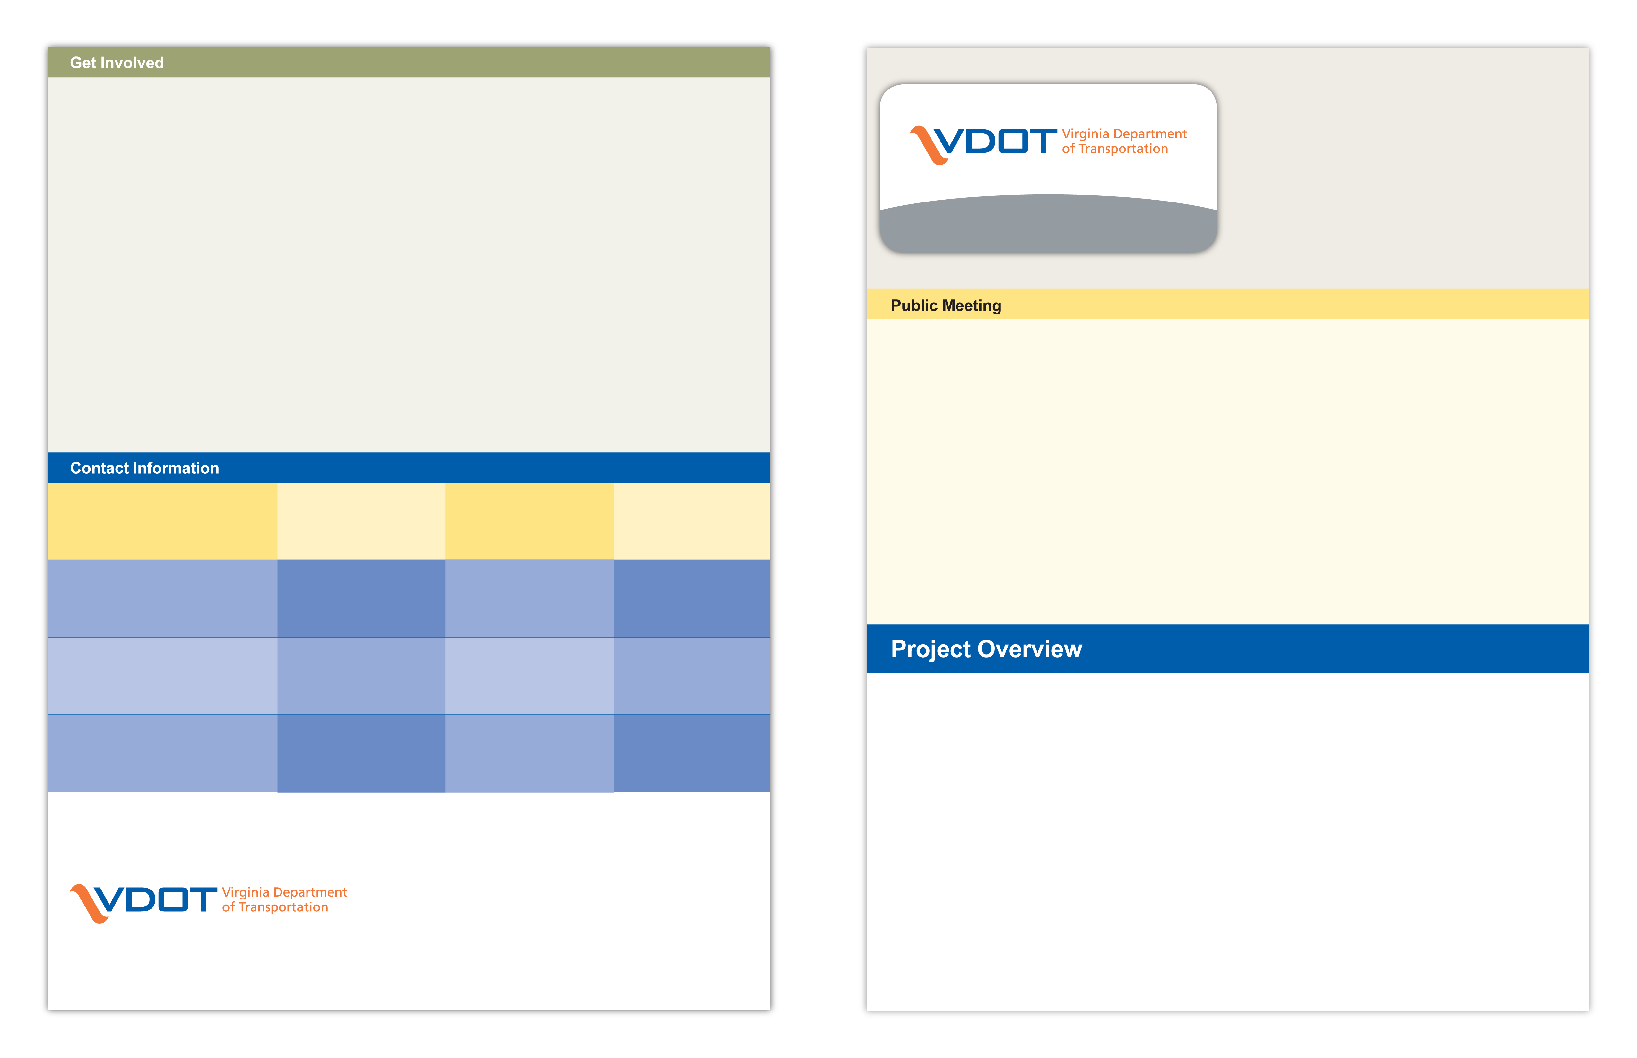

Design Public Hearing

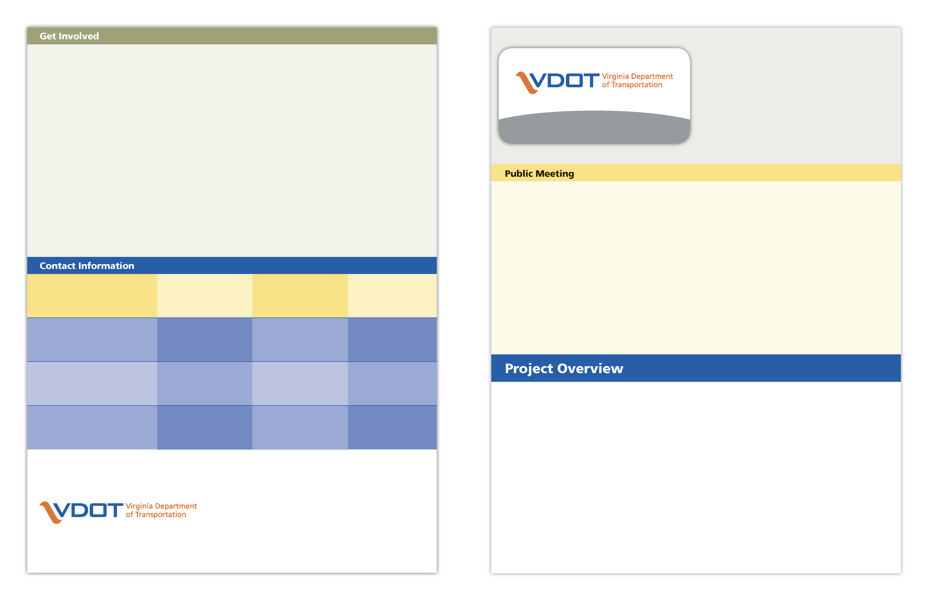Primary Contact:  Raina Rosado | Project Manager | 4219 Campbell Avenue  Lynchburg, VA 24501 | 434-856-8318
Brian Casto | Engineering Manager | 4219 Campbell Avenue  Lynchburg, VA 24501 | 434-856-8276
Len Stevens | Communications Manager | 4219 Campbell Avenue  Lynchburg, VA 24501 | 434-856-8176
Mike Sprouse | Regional Right of Way Manager | 811 Commerce Road  Staunton, VA 24401 | 540-280-3851

Available Allocations - $11.3 Million
Purpose – Improve safety/traffic flow
From – 0.17 mile west of CVCC Campus Dr.
To – 0.05 mile east of CVCC Campus Dr.
Project Length – 0.22 mile
Improvements –

- Construct a roundabout at this intersection
- Construct 500’ of sidewalk to tie in to existing sidewalk

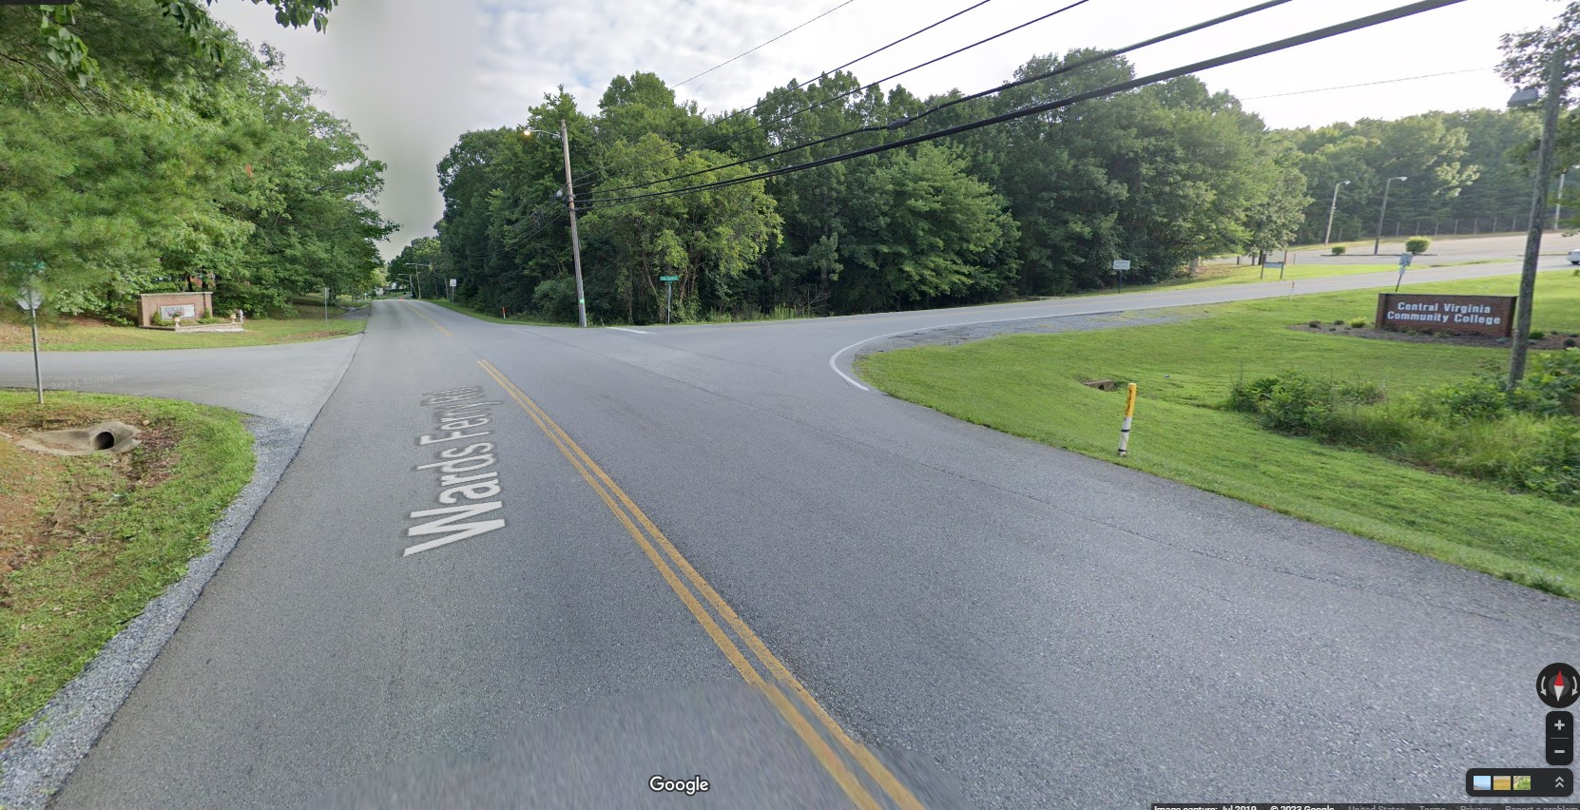
Wards Ferry Road and CVCC Campus Drive intersection, Lynchburg, VA
State Project: U000-118-312, P101, R201, C501
Federal Project: STP-5118(314) UPC: 119163

Total Cost: $12.2 Million
- Preliminary Engineering: $1.3 Million
- Right of Way and Utilities: $3.0 Million
- Construction: $7.9 Million
These costs are subject to change because development of the project is in its early design stages. The project will be funded using state and federal funds.

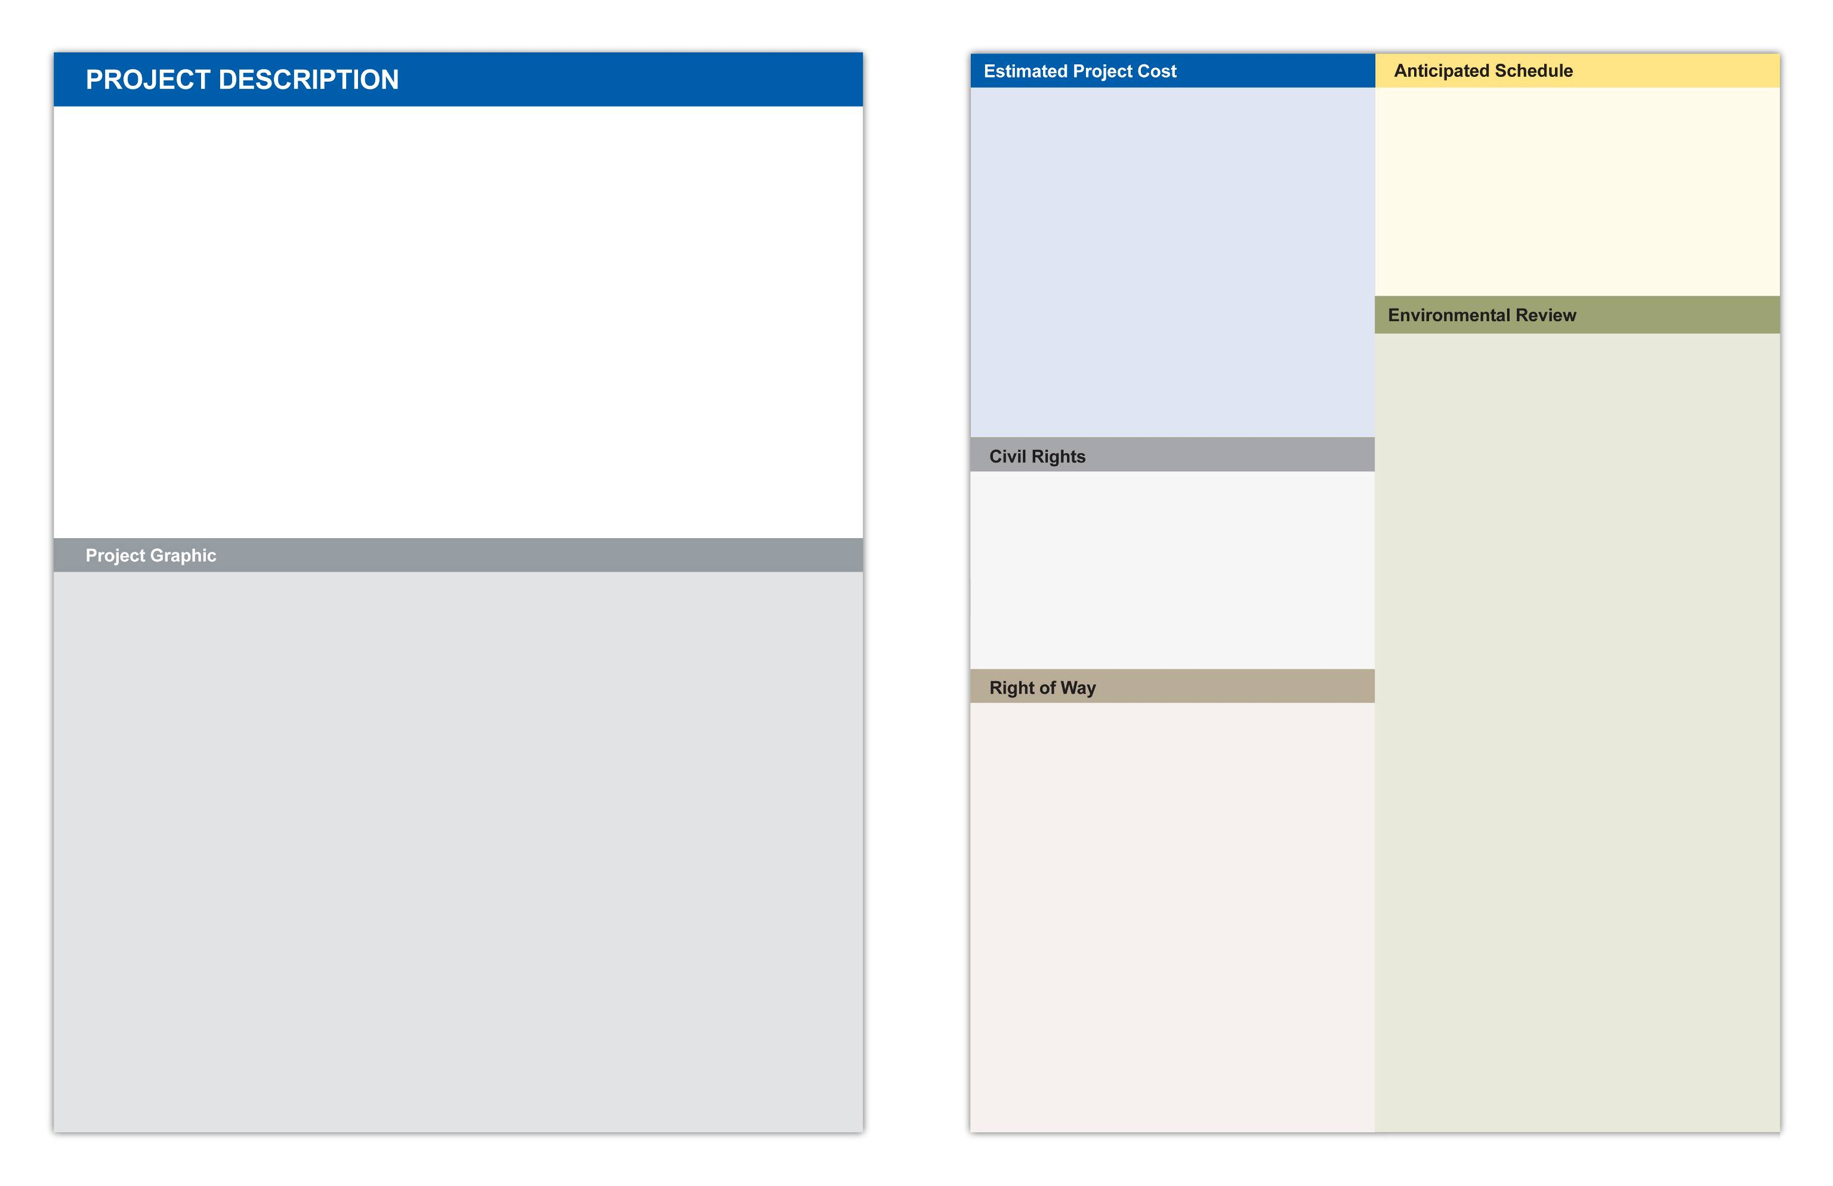
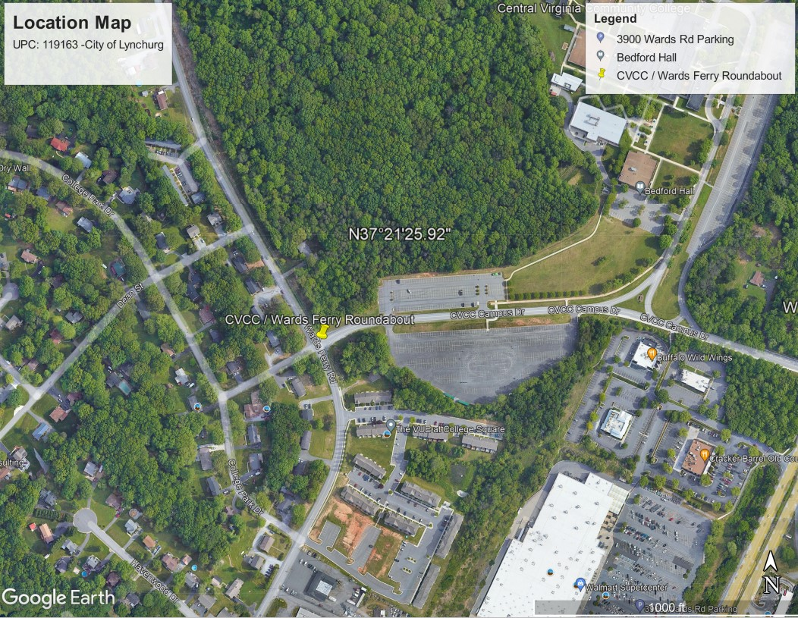

As VDOT further develops and finalizes this project, additional easements for utility relocation may be required beyond the proposed right of way shown on the public hearing plans.
Construction will not require the displacement of any families, businesses or non-profit organizations.
Information about right of way purchase is discussed in VDOT’s brochure entitled “Right of Way and Utilities: A Guide for Property Owners and Tenants. Copies of this brochure are available here.

After this meeting, information regarding right of way may be obtained from the right of way contact listed on the back of this brochure.

VDOT’s Lynchburg District Environmental Office has performed environmental reviews and coordination to obtain information about environmental resources in the project vicinity; to provide natural and historic resource agencies an opportunity to review and comment on the project during its development; and to identify opportunities for avoidance, minimization and mitigation of potential environmental impacts.

The National Environmental Policy Act (NEPA) is applicable to this project and a NEPA document in the form of a Categorical Exclusion has been developed in cooperation with the Federal Highway Administration and in accordance with federal guidelines. The NEPA document includes information from various technical reviews including those related to natural resources, water quality, cultural resources, threatened and endangered species, air quality, noise, etc.

The project will continue to be coordinated with the appropriate federal, state, and local agencies as part of environmental review and approval processes required throughout project development and construction. All required environmental clearances will be obtained prior to commencement of construction. Strict compliance with all environmental conditions and commitments resulting from regulatory approvals, and implementation of VDOT’s specifications and standard best management practices will protect the environment during construction.

The NEPA document and the results of other environmental studies are available at today’s meeting. Representatives from VDOT’s Environmental Section are available to discuss this information and to answer questions.

VDOT ensures nondiscrimination and equal employment in all programs and activities in accordance with Title VI and Title VII of the Civil Rights Act of 1964.

If you need more information in regards to your civil rights on this project or special assistance for persons with disabilities or limited English proficiency, contact the project manager listed on the back of this brochure.

The following schedule has been proposed for the project:

- Public Hearing – April 2023
- Advertise for Construct. Bids – Spring 2026
- Construction Begins – Summer 2026
- Construction Completed – Fall 2027

The purpose of this project is to improve safety for motorists and pedestrians at the Wards Ferry Road and CVCC Campus Drive intersection by constructing a single lane roundabout. The project limits are on Wards Ferry Road from 0.17 mile west of CVCC Campus Drive to 0.05 mile east of CVCC Campus Drive, a distance of 0.22 mile.

Project includes the construction of approximately 1200' of shared-use path in accordance with the Wards Ferry Road Corridor Plan and ties into existing sidewalk along Wards Ferry Road. Construct 500' of sidewalk to tie into sidewalk on CVCC campus connecting the proposed sidewalk improvement along Wards Ferry Rd. to the existing sidewalk network approximately 500 feet to the east along CVCC Campus Dr. The extension would create a continuous sidewalk network from Wards Ferry Rd. to Central Virginia Community College, Liberty University and commercial along the Ward's Road corridor.

The Wards Ferry corridor connects from Timberlake Road in the north to Wards Road in the South. Timberlake Road and Wards Road are both major gateways in the City of Lynchburg.

Wards Ferry Road serves as a heavily used collector facility that provides access to residential, commercial and institutional uses.

Temporary lane closures and traffic shifts may be necessary during construction. Access to all properties and businesses will be maintained during construction.

The design of this project is in compliance with the Stormwater Management Act, stormwater regulations and the annual stormwater management standards and specifications approved by the Virginia Department of Conservation and Recreation. Potential impacts to the flood plains will be evaluated and addressed on this project.
The construction of this project will conform to the nationwide best management practices, VDOT specifications and special provisions, and the Virginia Department of Soil and Water conservation regulations. Also, during construction, every reasonable effort will be made to protect the environment with respect to dust and erosion control.

