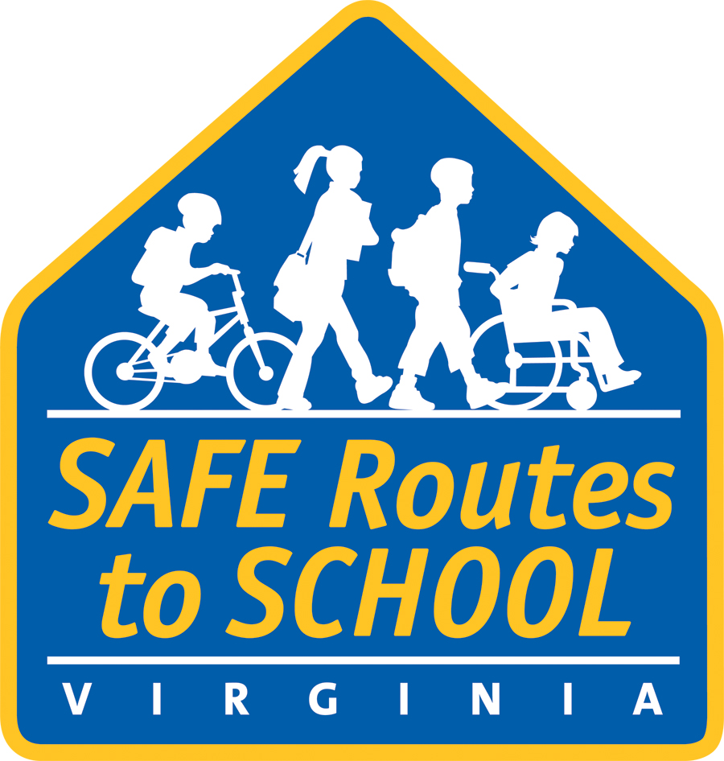
[City, county, area] School(s) to Celebrate
International Walk to School Day October [date]

WHAT: [Name of school, participating organizations, etc.] in [city] will join children and adults at schools around the world in celebration of International Walk to School Day on October [date].

WHO: [Name(s) of schools participating]
[Name(s) of community members participating]

WHERE: [Location such as where walkers will meet to walk together or streets children will be walking along. Include visual cues, e.g., next to the big oak tree]

WHEN: [Time, e.g., Gather at 7 AM, Walk to begin at 7:15 AM]

WHY: Approximately [number] students from [name of school(s) participating] will be walking to school [day(s) of the week] along with parents, teachers and community leaders. [Provide names and titles of any community leaders or prominent figures expected to participate].

International Walk to School Day events promote healthy lifestyles among children by encouraging them to walk or bike to school. More activity means healthier kids. Events like these emphasize ways to make the daily trip to school safe and fun. When children walk or bike to school, they make new friends and become more familiar with their neighborhood. And with more students on foot, traffic around schools is reduced.

October [date] is the “official” Walk to School Day, but events held anytime in the fall are recognized by the International Walk to School Day organizers.

The event is being organized by [organizing group(s)]. [Include additional information about your program and how it fits into the larger picture for the community, etc.]

About the Virginia Safe Routes to School Program
VDOT's Safe Routes to School Program (SRTS) assists interested localities and schools in the development of plans, activities, and infrastructure improvements to make bicycling and walking to school a safe and appealing transportation option for students in kindergarten through eighth grade. For more information, visit www.virginiadot.org/saferoutes.

###

