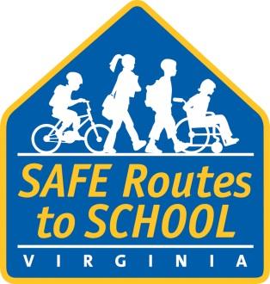

**[City, county, area] School(s) to Celebrate**

**Crossing Guard Appreciation Day**

**WHAT: [Name of school, participating organizations, etc.]** in **[City]** will join children and adults at schools around the state in celebration of Crossing Guard Appreciation Day.

**WHO:** **[Name(s) of schools participating]**

**[Name(s) of community members participating]**

**WHERE:** **[Locations where crossing guards will be honored, such as the intersections where they help students cross, or school assembly room]**

**WHEN:** **[February 7, 2024, and time, e.g., during morning arrival, or set time during the day]**

**WHY:** Approximately **[number]** students from **[name of school(s) participating]** regularly walk **[and bike]** to school with assistance from **[name of Crossing Guard].** In addition to helping the students that walk **[and bike]**, **[name of crossing guard]** also helps ensure bus riders and students dropped off by their parents all arrive at school safely. **[Add additional information or anecdote about crossing guard here.]**

The event is being organized by **[organizing group(s)]. [Include additional information about your program and how it fits into the larger picture for the community, whether it is part of a Safe Routes Virginia program, etc.]**

Safe Routes to School events, like Walk to School Day and Crossing Guard Appreciation Day promote healthy lifestyles among children by encouraging them to walk or bike to school. More activity means healthier kids. Events like these emphasize ways to make the daily trip to school safe and fun. When children walk or bike to school, they make new friends and become more familiar with their neighborhood. And with more students on foot, traffic around schools is reduced.

**About the Virginia Safe Routes to School Program**

The Virginia Department of Transportation's Safe Routes to School Program (SRTS) assists interested localities and schools in the development of plans, activities, and infrastructure improvements to make bicycling and walking to school a safe and appealing transportation option for students in kindergarten through high school. For more information, visit [www.virginiadot.org/saferoutes](http://www.virginiadot.org/saferoutes).

###